### Contract Processing Steps *(Implementation/Success to fill)*

### [*Garage Example of Contract Processed*](https://garage.tabsplatform.com/prod/contracts/4524b23a-d8f4-47d6-95d0-019560268d14/terms/revenue)

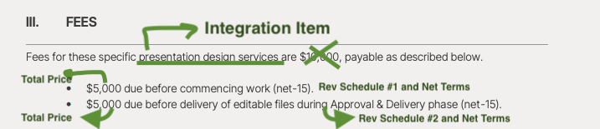

***For renewal contracts, process all BTs under the renewal contract.

**\*\*\*Contracts that already have a Sent /Paid invoice cannot have their Billing Terms changed.** New Edits / Additions / Requests from the merchant will have to go on an entirely new contract and will be on a separate invoice

* When you see a sent invoice on the contact in garage, ask the US team to duplicate the contract to put the new BTs under

1. Steps to process
   1. **Service Start Date:** Use the signature date of the contract. If no signature, use the date in the top left of the first page of the contract

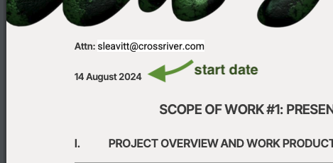f

* 1. **Total Months of Service:** Default 1 month
  2. **Item Name:** the project name (if not available in the email body, flag to US team)
     1. If the merchant sent an email asking to generate an invoice, match the item name with the integration item
     2. For example, “Raise an invoice for XXX customer for $4k. Integration item is Presentation Design”. Use Presentation Design as the item name.
  3. **Integration Item:** Scroll to **FEES** section
  4. **Total Price:** Refer to screenshot to find location of prices specific to contract, each bullet will be its own **REV SCHEDULE** and pricing might differ from bullet to bullet
  5. **Quantity:** Default 1
  6. **Start Date:**
     1. For first rev schedule, first bullet and payment: Start date will be the same as service start date
     2. For other bullets: you will make the start date 1 month after the service start date
        1. Example, if there are 2 bullets after the first one:
           1. The second line item will start 1 month after the start date
           2. The third line item will start 2 months after the start date
  7. **Frequency:** None, unless otherwise stated
  8. **Net Terms:** Refer to contract
  9. Product Description (FROM EMAIL):
     1. Add the "Product Name" Field from the email to the product description in the line item of the invoice. Example below in screen shots.

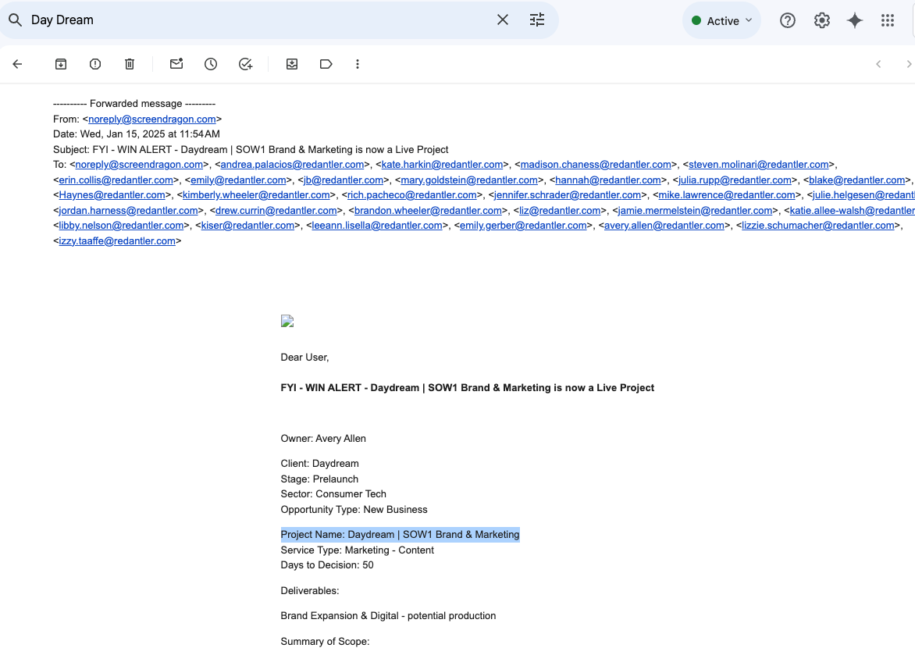

* + 1. Example Contract: a3f5017e-184f-49a8-aaa0-c8aa6f2abde4 (No action required, this is just for illustration)
       1. The "Project Name" field is "Daydream | SOW1 Brand & Marketing"
       2. RA 273 128bcd76-b466-42cc-a8c1-49d315d5a0b4 would then read "Agency Fees - Daydream SOW1 Brand & Marketing" for the line item on the invoice
  1. **CUSTOMER NAME:** Choose the customer from from what is specified in the email (not the filename)
     1. Customer Name: Special Instructions: Wild Fruit has two customers, one named **AceCap** and one named **Ace.** If you see “Ace” please double check to confirm you are updating the proper customer.
  2. [Create Project ID](https://docs.google.com/document/d/12lLuWc4reAQujnH98s-fRLztLe4-MCf_/edit):
     1. Customer Creation Workflow: Follow Red Antler Customer Creation Workflow. For Wild Fruit - [Client Director](https://docs.google.com/spreadsheets/d/1qCIN6wGx1HogoTmyguo3f-WeU17D5a2icS-AMObUrMM/edit?gid=0#gid=0) is Always Andy Meehan Director ID: ​​7577

1. Anything to ignore in contracts?
   1. Total price of services that is included in the first sentence of fees. Refer to the bullets
2. Specifics processing things the merchant has requested that may differ by contract (e.g. always back-date invoice date to final day of the month)
3. Default Service Term
   1. Refer to contract
4. Default Net Payment Terms
   1. Default 15 if none listed
5. Default Billing Frequency
   1. None if none is listed
6. How do we handle taxes as a line item?
   1. No tax

### Events Processing (if necessary) *(Implementation/Success to fill)*

* Any important information on events billing

Integration Items Processing (if necessary)  
*(Implementation/Success to fill)*

* Default integration item for wild fruit is: “Presentation Design - Wild Fruit” NOT “Professional Fees”

Post Processing Communications (if necessary)  
*(Implementation/Success to fill)*

* Does the Ops Team need to notify anyone on the team re: completion of processing batches in Implementation or Active phase?
* Who needs to be notified and when?
  + Example:
    - Who: Customer Success [Charlie Niesenbaum] needs to be notified
    - Where: Red ANtler merchant channel
    - When: contracts are processed [Merchant Phase: Active]